Vision Training with Binocular String
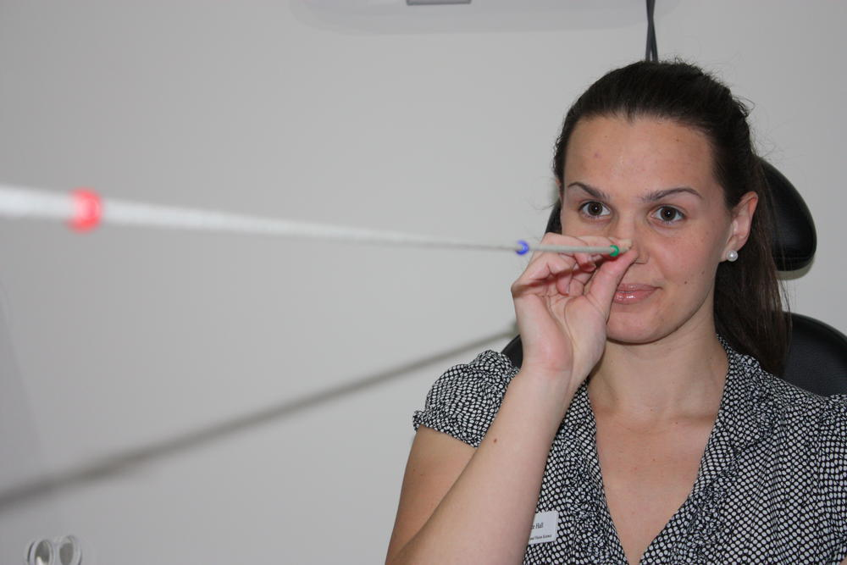
Binocular string exercises help to train convergence and help the eyes to avoid suppression. Convergence is when both eyes move inwards (towards the nose) as we look at objects up close. If our eyes do not converge, the near object will be seen as two (or doubled). For any reading or computer task we are converging the eyes different amounts to keep the image single.
Accommodation (focusing system of the eye) is closely linked to convergence as we have to keep the object not only single, but also clear. Problems with convergence can lead to double vision, blur, eye-strain, headache or fatigue when reading or doing close work.
If the visual system cannot control double vision well, the brain may suppress one eye, ignoring the input from it so that the world is not doubled. Suppression means the eyes are not working together to see binocularly and the eyes can no longer see the world three dimensionally, which can make visual training less effective.

What you will need
- A binocular string (available for purchase from Innovative Eye Care) with three coloured beads linked through a string.

Instructions:
- Attach one end of the string to a door knob or window latch.
- Hold the other end of the string in front of your nose so you are looking down the length of the string.
- Start with the three beads pushed away from you ‒ one at 15cm from your nose, one at the far end of the string and one in the middle at 30cm from your nose.
- Concentrate on the far bead. Make sure that this bead is single and clear. The two other beads should look fuzzy and double. Be aware that the beads that you are not looking at are double at all times; also be aware of the string and how it crosses at the bead you are concentrating on.
- If you can do this successfully, shift your concentration to the middle bead. This middle bead should now be clear and single, while the other two beads are double and fuzzy.
- Now shift your attention to the front bead and try to make it clear and single. The other two beads should now be double and fuzzy.
- Keep shifting your attention through the three beads for one minute (20 cycles).
If you can do this successfully we will gradually make the exercise harder by moving the closest bead towards you, first to 10cm, then 8cm, then 5cm for experts!
If at any stage the beads you are not concentrating on become single, it means you are now only using one eye and suppressing the other. In this case, you must move the beads back to a place where you can do the exercise without the wrong beads going double/fuzzy.
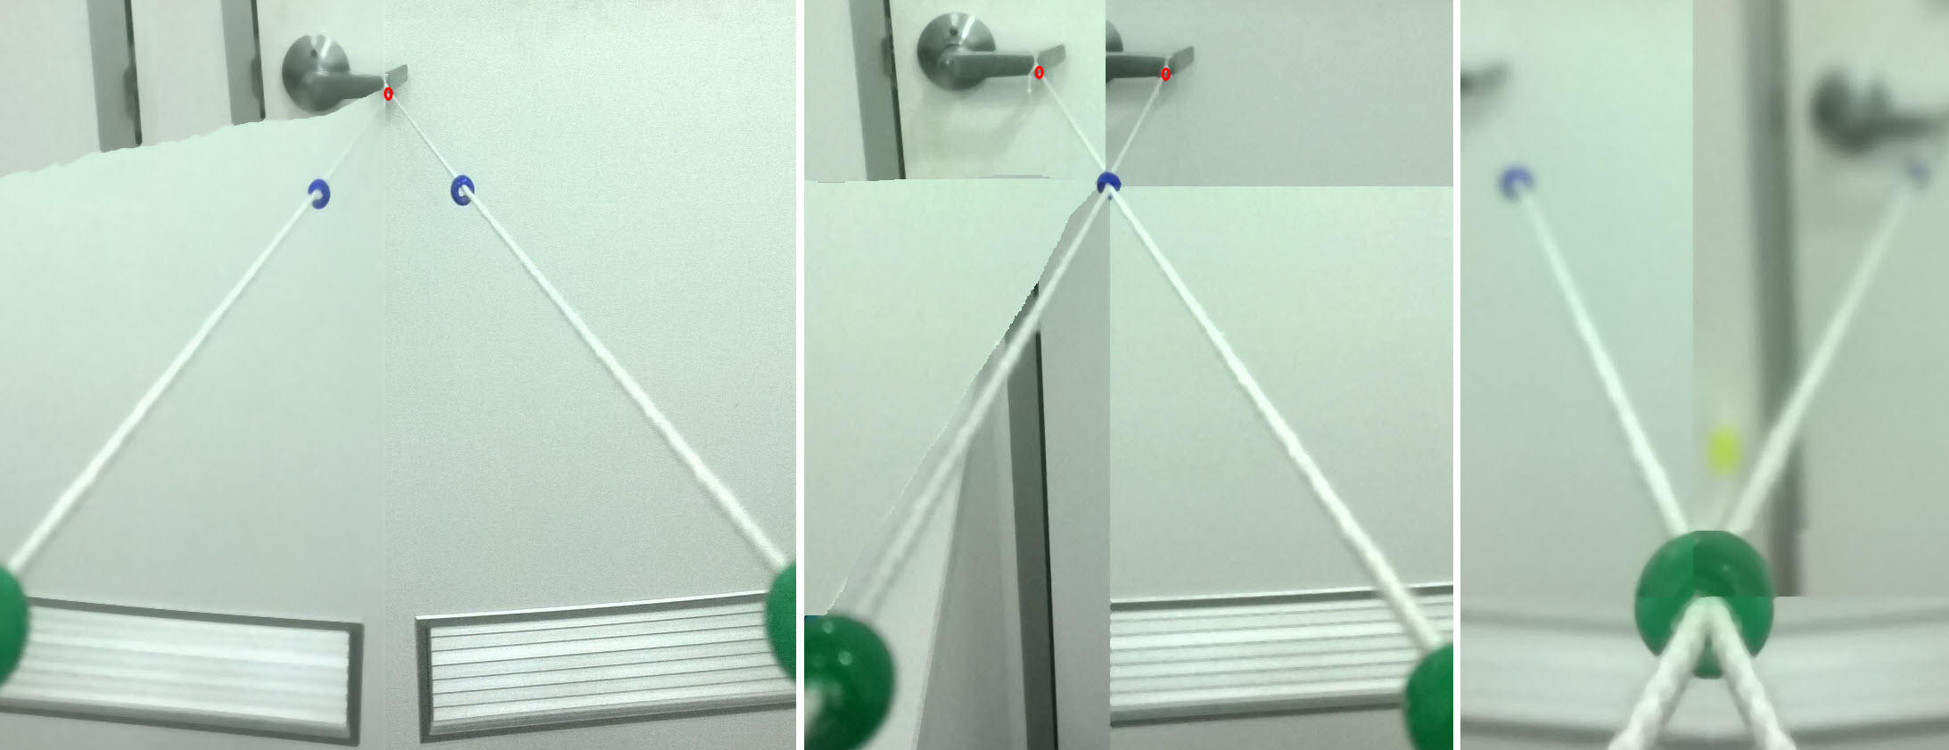
Figure 1. How to perform the brock string training exercise.
Repeat these one minute cycles three times, on at least three occasions during the day.
Remember: For these exercises to be effective, the bead you are concentrating on has to be kept single. If it doubles, you may need to start with the bead further away. If you have any questions, please contact us.

